

|  |
| --- |
|  |
|  |
| Production plant for Renewable Resources |
| H84PSD: Process Synthesis and Design Coursework Question 1 |
|  |

**Group 12**

Patrick O’Brien

Rosen Trichkov

Dariela Valdes

Hassan Miah

Guohao CUI

Contents

1 Introduction 2

1.1 Objectives 3

1.2 Assumptions 3

2 Overall Process 3

2.1 Reaction set 1: 3

2.2 Reaction set 2: 4

3 Results & Discussion 5

3.1 Reactor Heuristics 5

3.2 Attainable Regions 7

4 Phase separation 8

5 Distillation decision tree 8

5.1 First column 8

5.2 Second column: 9

5.3 Third column: 9

5.4 Fourth column: 9

5.5 Fifth column: 9

6 Separation Train & Marginal Vapour Analysis 9

7 Recycle Optimisation 11

8 Heat Integration 13

9 Economic Summary 14

10 Conclusion 15

11 Appendix 16

**Figure list**

|  |  |  |  |
| --- | --- | --- | --- |
| Fig no. | Figure description | Type | Page number |
| 1 | HYSYS simulation of first reactor | Image | 4 |
| 2 | HYSYS simulation of second reactor | Image | 5 |
| 3a | The attainable Regions for Reaction Set 1 | Graph | 7 |
| 3b | The attainable Regions for Reaction Set 2 | Graph | 7 |
| 4 | HYSYS image to display the reactor set up used to test attainable regions | Image | 8 |
| 5a | Distillation column decision tree | Image | 8 |
| 5b | HYSYS simulation of distillation columns | Image | 9 |
| 6 | PFR-100 recycle optimisation with regards to revenue. | Graph | 11 |
| 7 | PFR-101 recycle optimisation with regards to revenue | Graph | 12 |
| 8 | PFR-101 volume optimisation with regards to revenue | Graph | 12 |
| 9 | PFR-101 temperature optimisation with regards to revenue | Graph | 13 |
| 10 | HYSYS simulation relevant to the heat integration | Graph | 13 |
| 11 | Net Profit Present Value over time | Graph | 14 |

**Table List**

|  |  |  |
| --- | --- | --- |
| Table no. | Table description | Page number |
| 1 | Economical CO input | 5 |
| 2 | Economical H2 input | 5 |
| 3 | Economical H2 into the second reactor | 5 |
| 4 | Pressure in PFR-101 | 5 |
| 5 | Temperature into PFR-101 | 6 |
| 6 | Boiling point for every component | 9 |
| 7 | First three distillation columns separation components | 10 |
| 8 | Last two distillation columns separation components | 10 |
| 9 | Marginal Vapour Analysis for the first 3 columns | 10 |
| 10 | Marginal Vapour Analysis for the last 2 columns | 10 |
| 11 | Expenses and sources of income summary | 13 |
| 12 | Attainable Region Reaction set 1 | 15 |
| 13 | Attainable Region Reaction set 2 | 15 |
| 14 | Reflux rate in TEE-101 | 16 |
| 15 | Reflux rate in TEE-102 | 16 |
| 16 | Capital Costs CAPEX | 17 |
| 17 | Operations Costs OPEX | 18 |
| 18 | Total Revenue | 18 |
| 19 | NPV | 19 |

# 1 Introduction

Cargill generates 16 t/h of CO from agricultural waste which it was previously using as a fuel source for electrical power generation. New technology for sustainable chemical production with additional feedstocks of propene and hydrogen also produced by Cargill; indicate a greater return in investment if implemented. Through the utilisation of Aspen HYSYS, a process simulation has been carried out to optimise the economic feasibility of the conversion of the CO, H2 and propene to more expensive products such as i-butanal and i-butanol.

The brief:

* Adding greater value to renewable resources by producing sustainable chemicals from the propene, CO, and H2.
* Evaluate a conceptual design within a preliminary cost framework.
* Product purity > 99 % stored at ambient temperature.

## 1.1 Objectives

* Heuristics of the process for maximal economic production.
* Recycle to extinction to minimise waste.
* Use of Heat integration to minimise utility use.
* Optimizing considerations based on operating costs.
* Production of highly pure (>99% mol/mol) i-butanal and i-butanol products.

## 1.2 Assumptions

Negligible pressure drops across the reactors, steady state operation, Liquid level set to 50% by default. Plug flow no-radial variations in velocity, concentration, temperature, or reaction rate. Perfect mixing in the continuous stirred tank reactors (CSTR). Furthermore, the distillation columns have been assumed to be highly efficient with minimal pressure drop.

## 2 Overall Process

### 2.1 Reaction set 1:

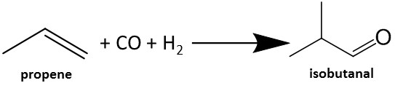

**Reaction 1**

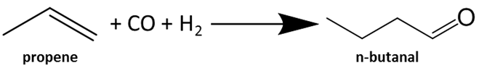

**Reaction 2**

The reactions present in reaction set 1 occur in the first reactor (PFR-100), with an emphasis being put on the production of i-butanal rather than n-butanal due to I-butanal being the feed for the next reaction. The conditions of the inlet stream to the reactor were tested to maximise the production rate of reaction 1 and minimise the conversion occurring in reaction 2. Figure 1 displays the overall HYSYS simulation related to the reaction set 1, with a recycle being implemented to optimise the total amount of i-butanal produced.

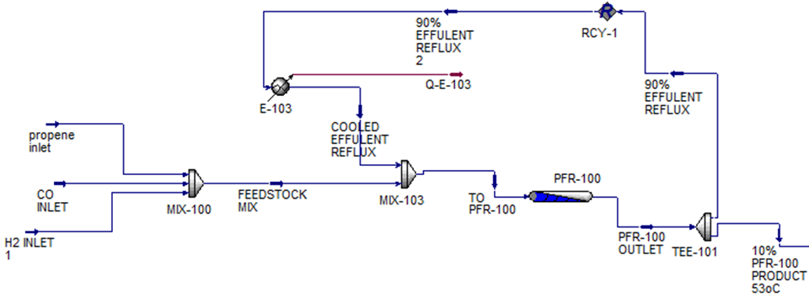

Figure 1: HYSYS simulation of first reactor.

### 2.2 Reaction set 2:

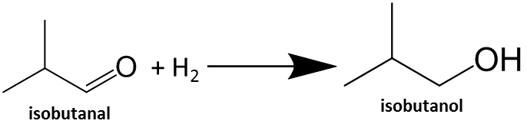

**Reaction 3**

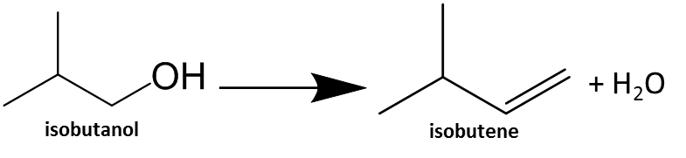

**Reaction 4**

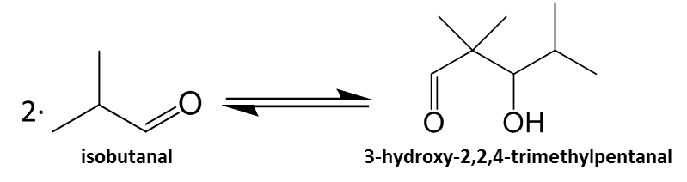

**Reaction 5**

Reaction set 2 occurs in the second reactor (PFR-101). Originally a CSTR was suggested as the appropriate reactor for use by the lab team, however different reactor combinations were tested with the PFR reactor producing the best results. The inlet conditions as well as length and diameter of the reactor are optimised to produce the highest amount of i-butanol possible while also ensuring that reaction 5 is shifted to the left as much as possible and reaction 4 is avoided as much as possible. Further to this excess amount of H2 is supplied to ensure that reaction 3 is promoted as much as possible. Figure 2 shows the approach taken when simulating the second reactor in HYSYS with an emphasis being put on ensuring that the inlet conditions to the reactor are as optimal as possible for maximum profit to be obtained. Figure 2 also shows the precursor step in the separation process where the outlet of the second reactor is cooled for most of the H2, CO and CO2 to be removed prior to the distillation process.

Recycling until extinction occurs in the second reactor by recycling the 3-hydroxy-2,2,4-trimethylpentanal to prompt the reverse of reaction 5 and therefore will be a greater availability of i-butanal.

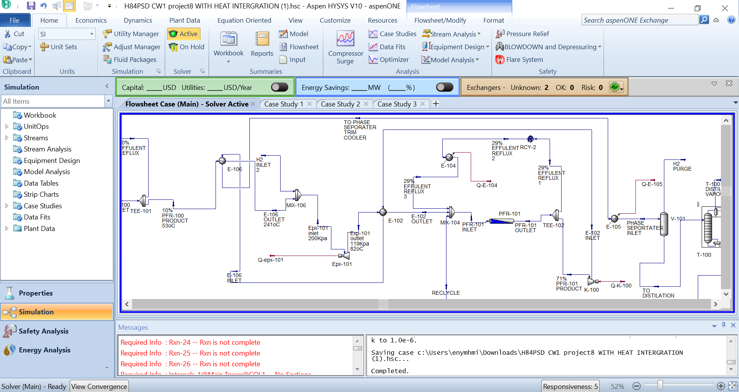

Figure 2: HYSYS simulation of second reactor.

# 3 Results & Discussion

## 3.1 Reactor Heuristics

Table 1: Economical CO input.

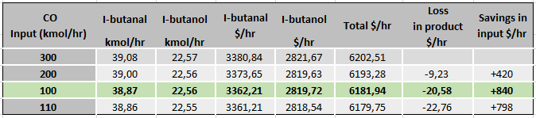

As it can be seen by table 1, the feed CO molar flow rate to PFR-100 was varied in order to determine the most economically viable option. It was found that despite the reduction in the overall production of i-butanol and i-butanal, reducing the CO input from 300 to 100 kmol/hr saves approximately 820 $/hr in total as the loss in product is minimal when compared to the savings made from the lower amount of CO used.

Table 2: Economical H2 input.

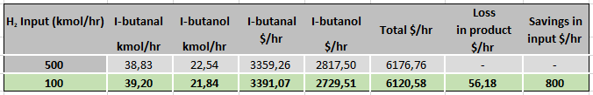

Similarly, to the CO feed, the H2 input feed to PFR-100 was reduced from 500 to 100 kmol/hr which results in total savings of approximately $745/hr (table 3).

Table 3: Economical H2 into the second reactor.

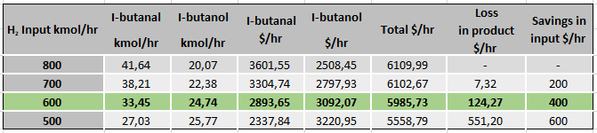

Hydrogen input to PFR-101 was varied and reduced from 800 to 600 kmol/hr to save around 280 $/hr as it can be seen in table 3.

Table 4: Pressure in PFR-101.

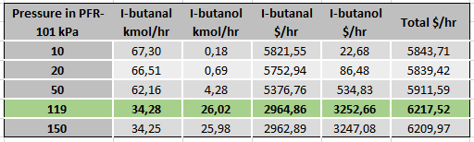

Optimisation of the operating pressure of PFR-101 was carried out. It can be seen in table 4 that using a pressure of 119 kPa produces the highest profit, therefore an expander is used to lower the pressure from 300 kPa to 119 kPa, recovering some energy in the process.

Table 5: Temperature into PFR-101.

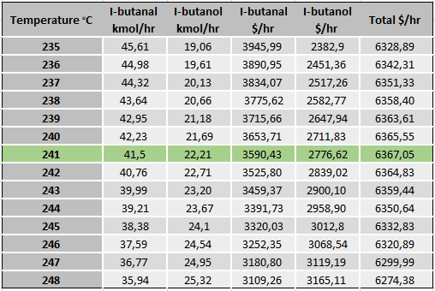

Optimisation of the temperature in PFR-101 was carried out using the case study and optimiser functions in HYSYS. The optimum temperature was found to be 241oC as it maximises the attainable profit.

## 3.2 Attainable Regions

Figure 3a: The Attenable Regions for Reaction Set 1

In figure 3a comparisons between reactor arrangements are made and it is shown that PFR with effluent reflux provides maximum I-butanal production.

Figure 3b: Comparison between different reactor configurations for the second reactor (Reaction Set 2).

Figure 3b shows that a PFR with effluent recycle gives the best attainable regions for the second reactor as it maximises the conversion and selectivity of reaction 3.

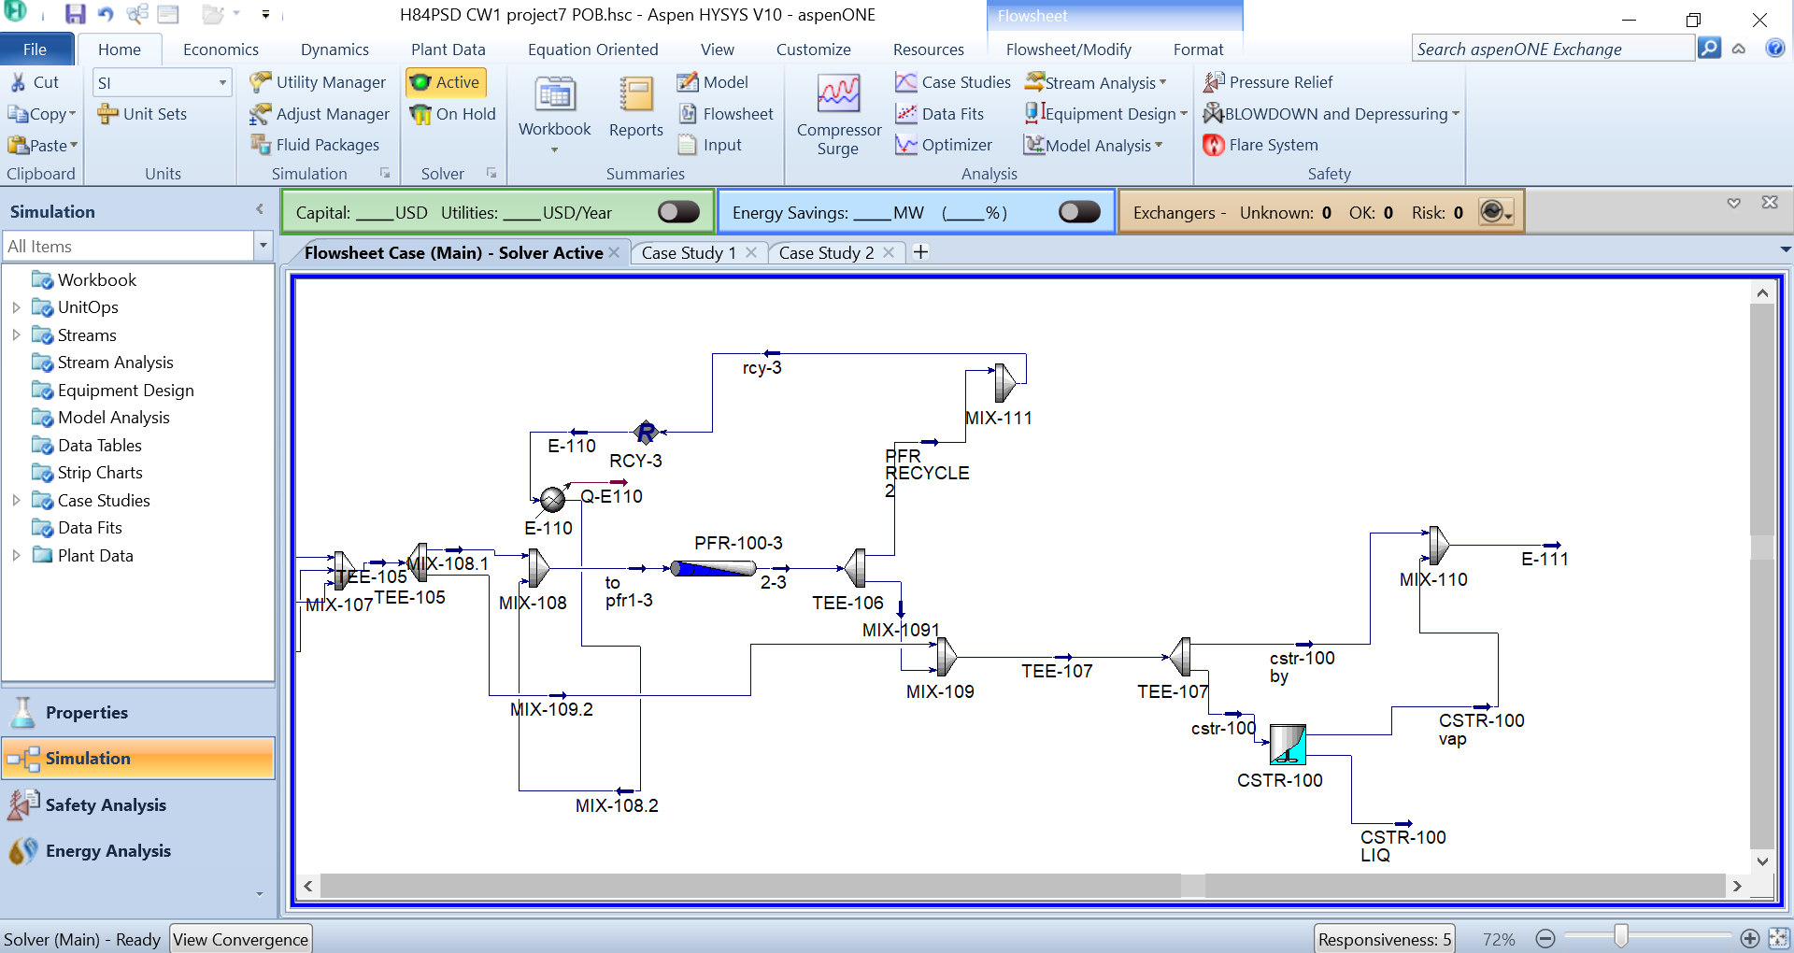

Figure 4: HYSYS image to display the reactor set up used to test attenable regions

## 4 Phase separation

We desired to remove the incondensable components before the distillation train is completed by cooling the mixture to -60oC and increasing the pressure just before the separator (V-101) to stop the liquids from freezing, at this temperature the pressure is increased to 300 KPa. Most of the H2, CO and CO2 are then purged to atmosphere as recycling caused a decrease in product formation.

5 Distillation decision tree

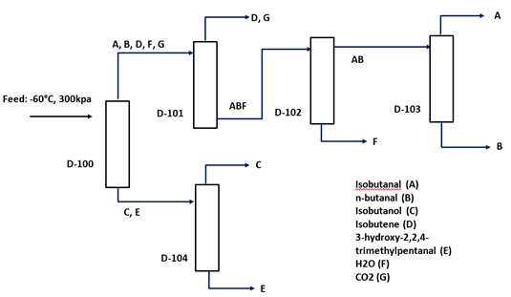

Figure 5a: Distillation columns decision tree configuration.

### 5.1 First column

The first column (D-100) contains 10 stages and is used to separate out the two most volatile components, i-butanol and the 3-hydroxy-2,2,4-trimethylpentanal, both removed in the reboiler stage. The conditions used in this column were varied to make sure that the maximum possible recovery of the i-butanol and was 3-hydroxy-2,2,4-trimethylpentanal achieved. The optimal inlet temperature and pressure were found to be -60°C and 300 kPa respectively with the column operating at a pressure between 295-305 kPa.

### 5.2 Second column:

The second column (D-104) contains 10 stages and is used to produce highly pure (>99% mol/mol) i-butanol as well as 100% pure 3-hydroxy-2,2,4-trimethylpentanal which is recycled back into the second reactor PFR-2. A Joule-Thomson valve is used to reduce the pressure of the inlet liquid stream to 100 kPa to maximise the recovery while keeping the number of stages as low as possible.

### 5.3 Third column:

The third column (D-101) has 14 stages and it is used to remove the remaining H2, CO2, CO and i-butene which come off the distillate of the column. The operating pressure has been optimised to be 295 kPa to achieve the best possible separation, with a cooler reducing the temperature of the feed to -20°C for the same reason.

### 5.4 Fourth column:

Column (D-102) has 24 stages and is used to remove the water that is present in the stream as a sufficiently good separation of the i-butanal cannot be achieved if the water is not removed first. In order to achieve this with the lowest possible stages the pressure needed to be reduced to 115 kPa.

### 5.5 Fifth column:

The final column (D-103) has 20 stages with a feed containing mostly i-butanal and n-butanal. A recovery of 96% of highly pure i-butanal is achieved by running the column at a feed pressure of 100 kPa with the condenser being at 20 kPa while the reboiler at 100 kPa, this is the best recovery possible due to the low difference between the boiling points of i-butanal and n-butanal.

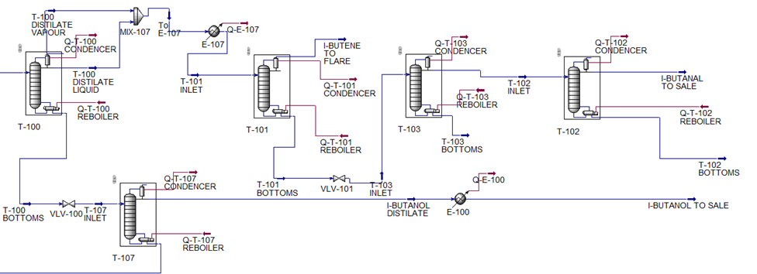

Figure 5b: HYSYS simulation of distillation columns.

## 6 Separation Train & Marginal Vapour Analysis

Several different separations units sequence trialled for optimum separation to be obtained. A focus on most volatile components removed first, these were I-butanol and 3-hydroxy-2,2,4-trimethylpentanal (HTP). The i-butanol separated is further purified to reach 99% purity as this is the process plant main product selling at 125$/kmol. The HTP has a lower market rate at 15.1$/kmol, i-butanal market rate is at 86.5$/kmol. Process was optimised accordingly to recycle HTP to PFR-101 to shift the equilibrium reaction 5 to produce more I-butanal. A third distillation column was implemented to remove undesired product such as H2, CO2 and i-butene. Afterwards, the i-butanal needs to be distilled to a 99% mol/mol purity. To do so, the water that was produced in reaction 4 needs to be removed as good separation cannot be achieved if water is present in the stream entering the final column; hence aids in purifying the i-butanal. Therefore, two more distillation columns were implemented with a sixth column to purify the n-butanal to be sold. However, it was removed later as the cost associated with an extra distillation column is too high to sell n-butanal this is because a high number of stages and high reflux ratio, with only a relatively small amount of n-butanal produced in comparison, making it a non-viable option to sell.

Table 6: Boiling point for every component

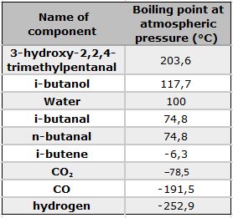

Table 7: First three distillation columns separation components.

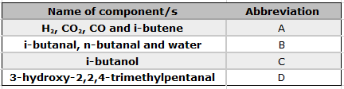

Table 8: Last two distillation columns separation components.

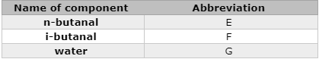

Table 9: Marginal Vapour Analysis for the first 3 columns.

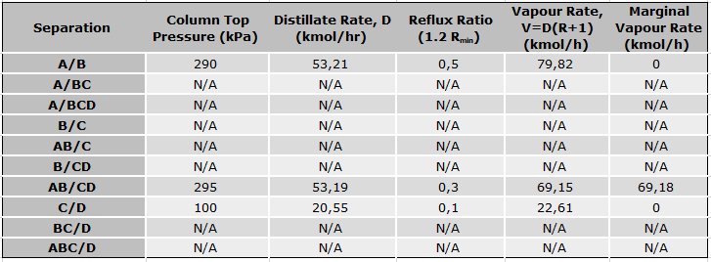

Table 10: Marginal Vapour Analysis for the last 2 columns.

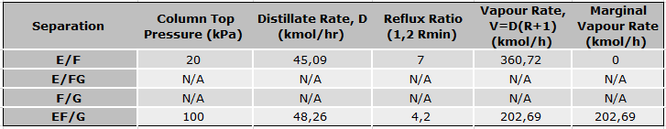

The heuristics for the favourable distillation column configurations can be seen in tables 9 and 10. The five distillation columns were split into two sections; in the first section the more volatile components were distilled including one of the two products to be sold, i-butanol. In the second section, fewer volatile components were separated out, including the i-butanal which is the main reaction product. The optimal separation train configuration was both determined by the boiling points of the different mixtures table 6 as well as by testing different configurations as seen in tables 9 and 10. There was only one separation train which produced the desired purities of the products, with the rest that were trialled being unable to be converged on HYSYS.

## 7 Recycle Optimisation

Figure 6 : PFR-100 recycle optimisation with regards to revenue.

Figure 6 shows the maximum production profitability at $6220/hr of the process plant production when the PFR-100 effluent is split and 10% of it is sent to distillation. Therefore, in HYSYS the effluent recycle is set to 90% back to PFR-100 inlet stream.

Figure 7 : PFR-101 recycle optimisation with regards to revenue

Figure 7 shows the maximum production profitability at $6250/hr of the process plant production when the PFR-2 effluent is split and 71% of it is sent to distillation section of the plant. Therefore, in HYSYS 29% of the effluent is recycled back to the PFR-101.

Figure 8: PFR-101 volume optimisation with regards to revenue.

Figure 8 shows the maximum production profitability at $6399/hr of the process plant production, when the PFR-101 volume is at 115m3, PFR-101 can generate the maximum product rate. In HYSYS the PFR-101 volume is set to 100m3 this volume roughly gives the same product income at $6356 but with a lower capital cost for the PFR-101.

Figure 9: PFR-101 temperature optimisation with regards to revenue.

Figure 9 shows the maximum production profitability at $6350/hr of the process plant production when the PFR-101 inlet temperature is at 241℃, PFR-101 can generate the maximum product rate. Therefore, in HYSYS the PFR-101 inlet temperature is set to 241℃.

## 8 Heat Integration

The addition of 2 heat exchangers E-106 and E-102 allow the PFR-101 prefeed to be heated by the effluent of the reactor.



Figure 10: Aspen HYSYS simulation relevant to the heat integration

The reactor effluent temperature is 277°C which is used though heat interchangers. 71% of PFR-101 effluent is passed through a heat interchanger that heats up the PFR-101 inlet feed to 241°C at E-102; another heat interchanger at E-106 also heats up incoming feed stream to 241°C. Heat integration save the plant 280 $/hr.

# 9 Economic Summary

Table 11: Expenses and sources of income summary.

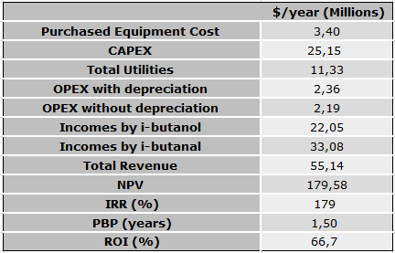

The total capital investment for this plant and all equipment selected in the design stage $25.15 million. Operation cost includes raw materials, utilities, human resources and depreciation is currently at $2.37 million/yr. The products sold are i-butanol and i-butanal; the revenue from these products comes to $55.15 million/yr.

Figure 11: Net Profit Present Value over time.

As it can be seen in figure 11 and table 11, the payback time to recover the capital invested is approximately 1.5 years, including the time required for construction. The initial investment was $27.52 million and from the graph we can see NPV of $273.4 million over the 10 years.

# 10 Conclusion

In conclusion, the process has been optimised to produce the best techno-economic plant configuration possible by using the Aspen HYSYS simulation environment. Plug flow reactors with a recycle loop were found to be the most optimal for both reactors, with 5 distillation columns being used for the separation due to the large number of distillation components at the inlet of the first column. It has been found that selling both a high amount of highly pure i-butanal and i-butanol results in a larger profit than when the highest possible conversion to i-butanol is used. This is mainly due to the increase in revenue not being sufficiently high for the added cost of a higher feed flowrate of hydrogen and CO. The remainder of the possible products have not been sold as their flow rates are not sufficiently high for the added cost of the extra distillation columns that would be required.

Overall, the plant has a revenue of $55.15 million/yr with a capital cost of $25.15 million/yr, with the operating cost annually being $2.37 million/yr, thereby giving a payback period of 1.5 years.

# 

# 11 Appendix

Table 12: Attainable Region Reaction set 1

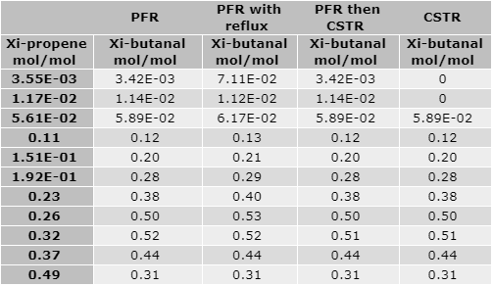

Table 13: Attainable Region Reaction set 2

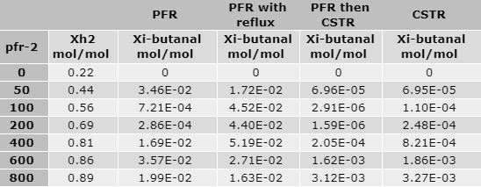

Table 14: Reflux rate in TEE-101

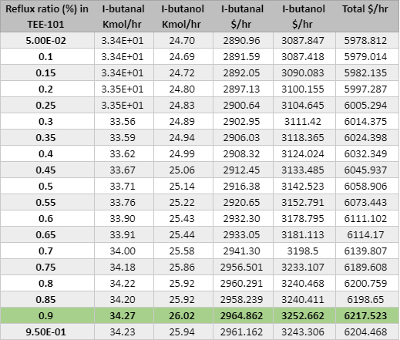

As the table 14 showed, 90% reflux rate brings the most products. That is why we recycled 90% in TEE-101.

Table 15: Reflux rate in TEE-102

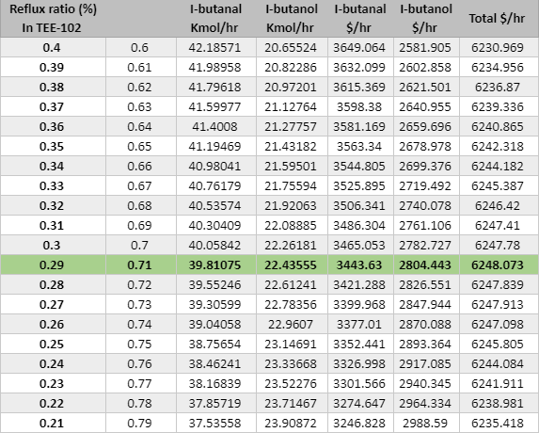

As the table showed, 29% reflux rate brings the most products. That is why we recycled 29% in TEE-102

Table 16: Capital Costs CAPEX

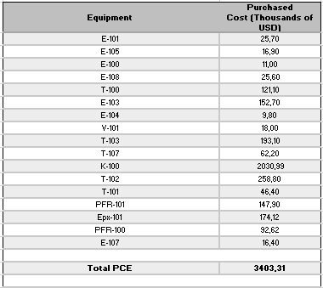

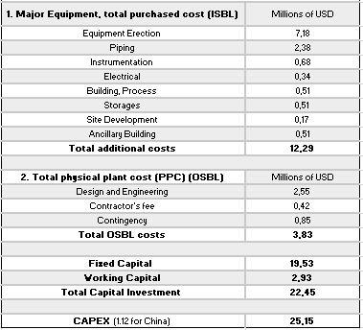

Table 17: Operations Costs OPEX

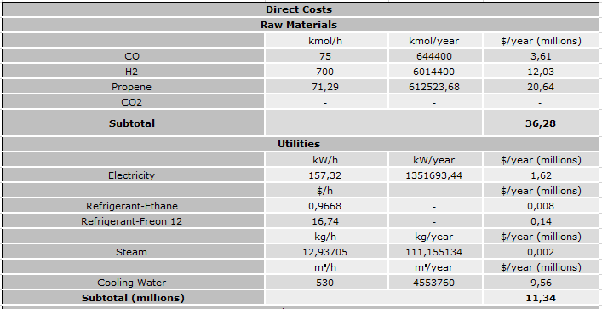

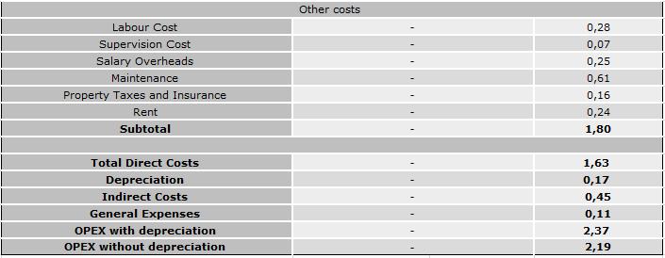

Table 18: Total Revenue

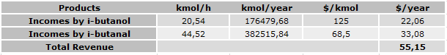

Table 19: NPV (Millions of USD)

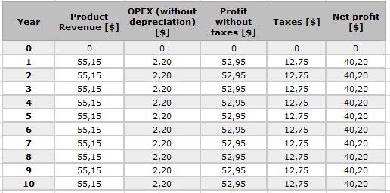

Table 19: NPV (continuation)

